**Report on Enhancing RNN Text Generation**

**Abstract:**

By adjusting hyperparameters, this study investigates how to optimize Recurrent Neural Networks (RNNs) for text production. The emphasis is on the effects of different hyperparameters on the model's capacity to produce coherent text, such as the number of RNN units, dropout rates, and batch sizes. It highlights how crucial properly adjusted hyperparameters are to improving deep learning models' precision and effectiveness in tasks involving natural language processing.   
  
The RNN architecture selection, hyperparameter optimization, and the use of sophisticated optimization methods, such as the Optuna framework, are all covered in the study. Extensive testing reveals that moderate batch sizes, larger dropout rates, and smaller RNN units enhance validation accuracy. The study also emphasizes the role of dropout and the fact that additional RNN units don't always translate into better results.

With 200 RNN units, a 0.30 dropout rate, and a batch size of 32, the optimal setup produced a validation accuracy of 0.038. This work establishes the foundation for creating more complex models for certain NLP applications and provides insightful information about RNN optimization for text generation.

**Introduction:**

With the advent of deep learning, this field of natural language processing has seen significant change, frequently enabling computers to produce writing that is not only coherent and contextually relevant but also remarkably human-sounding.   
Text production is a key component of natural language processing and has a wide range of uses, from complex content creation tools to fully functional automated chatbots and virtual assistants. RNNs serve as the foundation for all of these sophisticated applications. Because RNNs can manage dependencies in the incoming data and preserve internal states, they perform exceptionally well with sequential data. Large data sets have demonstrated the amazing abilities of deep learning models, particularly RNNs, in discovering the underlying linguistic structures and patterns. This makes it quite simple to create text sequences that are both contextually appropriate and grammatically correct.   
Models like GRU (gated recurrent units) and LSTM (long short-term memory), for instance, have attempted to broaden the range of text generation and achieve state-of-the-art outcomes in a variety of such varied tasks, including machine translation, text summarization, and even creative writing.

The key to creating such models, though, is that their performance is heavily influenced by hyperparameters like the number of units in each layer, dropout rates, learning rates, and others. Because it directly impacts how effectively the model generalizes from training data to unidentified data without overfitting, hyperparameters must be changed. In deep learning, overfitting is a prevalent issue where models perform exceptionally well on training data but fall short on new, unknown data.

Model optimization in natural language processing (NLP) aims to maximize the use of memory and processing power while simultaneously increasing accuracy and decreasing errors. Because they cut down on training time and computational expenses, optimized models are essential for real-time applications and environments with restricted resources. This makes NLP solutions more sustainable and accessible. By facilitating quicker, more precise responses in practical applications like media and healthcare, optimization also improves user experiences. This study investigates efficient RNN hyperparameter tuning strategies, such as Optuna, to boost model performance and further the more general objective of increasing NLP's resilience, effectiveness, and adaptability across a range of applications.

**Text Generation with Recurrent Neural Networks:**

Because recurrent neural networks operate fluidly with consecutive inputs, they have shown to be quite significant and have offered a means of raising the bar for text generation. The gradients that vanish or explode in typical RNN networks may experience issues that prevent them from learning lengthy sequences. Long Short-Term Memory units and Gated Recurrent Units were created as extensions to address this issue. By controlling the information flow, gated structures support the learning process's stability and efficacy, enabling the model to retain data across longer periods without experiencing information degradation.

Chirkova et al. (2018), for example, describe the Bayesian sparsification technique of RNNs, which enables extremely high model compression. Without adjusting specific hyperparameters, the method makes no real attempt to make the model too small, yet at simultaneously improves the interpretability of the word choice process, which is crucial for rapid text output.

**Developments in Hyperparameter Adjustment Methods:**

Since adjusting hyperparameters has an impact on neural network performance, this is a field of continuous research. In addition to being computationally costly, traditional grid search and random search are ineffective for exploring hyperparameter spaces. Other More sophisticated techniques include Bayesian optimization, which can model the hyperparameter function using a Gaussian process, and gradient-based optimization, which can optimize hyperparameters using gradients from the learning process. As a result, the latter has become more and more popular recently.

As demonstrated in "Online Hyperparameter Optimization by Real-Time Recurrent Learning" by Im et al., 2021, hyperparameter adjustment is incorporated into the RNN training process using a unique methodology. Online learning allows for the real-time learning of hyperparameters.   
  
Five methods with parameters that are comparable to those of an RNN. It does, however, eschew the idea of discrete validation phases to allow the data to adapt more dynamically and efficiently in the context of ongoing learning.

A time-constrained hyperparameter tuning framework that uses hierarchical network synopses to expedite the process was further developed by Guo et al. in related research. Just-In-Time Hyperparameter Tuning for this is known as JITuNE.   
Algorithms for network embedding. Its main advantage is that it is expected to have models that are deployed as efficiently as possible in the shortest amount of time.

**Impact and Implications:**

In keeping with text production hyperparameter adjustment, it's actually a part of a larger movement toward more adaptable, efficient, and scalable model training. By doing this, scholars and practitioners can create more accurate models that are dependable, computationally effective, and are able to function effectively under such tactics.   
When it comes to creating real-time language processing systems that prioritize performance and speed, this will be crucial.   
Research on RNN-based text creation and hyperparameter tweaking is often quite active and quick-paced, with robust studies continuously expanding the capabilities of these technologies for practical uses.

**Gathering Information and Creating Models**

**Description of the Dataset and Preprocessing Procedures**

The dataset used in this study is a collection of news headlines that were manually chosen from Kaggle for tasks involving text synthesis. The diverse range of headlines in this dataset provides a solid foundation for training and evaluating the RNN model. This dataset is a great option for developing a model that can comprehend and generate contextually rich text because the headlines cover such a wide range of topics.

After that, the dataset underwent a few more crucial preparation steps to get it ready for input into an RNN. To avoid discrepancies when the model handled the same words as distinct tokens, the headlines were first changed to lowercase since they took place in a separate instance.   
To streamline the model's learning process and decrease the quantity of unique terms in the lexicon, the punctuation has been eliminated. The cleaned text must then be tokenized, which entails turning each headline into a series of tokens.

This stage is crucial because it transforms textual data into a numerical format that neural networks can understand. To ensure that each input sequence had the same length, batch processing in neural networks was made possible networks, we used padding to get ready for the training process. To standardize the length of the sequences without sacrificing their meaning, we appended zeros to the beginning of each one.

**Architecture of the RNN Model:**

The most basic type of RNN for sequence data is called SimpleRNN. The architecture used in this study for text production appears to function effectively in practice. This model consists of a dense output layer with a softmax activation, an embedding layer, and a SimpleRNN layer function. The input is transformed into dense vectors of a predetermined size via an embedding layer, which preserves the semantic links between words. A SimpleRNN layer then processes the embeddings to extract context information from a sequence and preserve it further to produce a fluid text sequence. In the final step, word samples are generated at each stage of a sequence using a probability distribution across the words for text analysis.

**Rationale Behind the Choice of SimpleRNN and Hyperparameters:**

Because of the relative simplicity of the dataset's requirements, SimpleRNN is vulnerable to problems like vanishing gradients, while being chosen for its seeming simplicity and efficiency. When creating text, the long-term because translation and text summarization tasks are more crucial than dependencies, SimpleRNN strikes a balance between computational economy and performance.

To maximize performance, we have carefully selected the model's hyperparameters. Instead of interpolating from limited datasets, it appears that this approach has tendency to preserve information. The RNN units and the embedding dimension were tailored to avoid overfitting while accurately capturing the intricacy of the text data. Here, it served as a method for applying dropout to do regularization to prevent overfitting. If dataset diversity tends to make models too fit, this works incredibly well. To discover a balance between how quickly training should be completed and still having a good learning rate, exploratory experiments were conducted to determine an ideal learning rate and batch size.

The RNN model was strategically created and configured by carefully adjusting the hyperparameters so that the SimpleRNNs' inherent strengths produced a model that functions as best it can to provide reliable news headlines.

**Model Training and Hyperparameter Optimization**

**Setup and Execution of Model Training:**

The training of the model for the text generation job was carefully built up to guarantee that the recurrent neural network learns efficiently from the preprocessed dataset of news item headlines. The model's meticulously designed layers are up to the challenge of managing the intricacies of sequence prediction inherent in text generating activities. The Sequential framework from Keras is used in its construction.

The first layer, known as the embedding layer, allows for the tokenization of words into dense vectors and the capturing of minute semantic similarities across different phrases. The first of the two SimpleRNN layers that follow is configured to to preserve the time sequence and feed it into the following levels, return_sequences=True.   
To avoid overfitting, the training procedure is regularized and interspersed with Batch Normalization and Dropout layers. A probability distribution across the words that could appear in the resulting text is provided by the last Dense layer. Softmax is the activation that is utilized.

The assessment metric for model construction using Adam optimization and loss function categorical cross entropy is accuracy. Validation splits are incorporated into the training process to ensure the model can generalize to new, unseen data, in addition to preset settings, to verify overfitting.

Additionally, based on the findings of interim validation, the TFKerasPruningCallback from Optuna prunes unpromising trials for increased search efficiency. After the trial is done numerous times, Optuna provides the optimal set of hyperparameter settings, records, and utilizes it in the model's final configuration. The results of hyperparameter optimization are better: a batch size that guarantees stable training dynamics, an intermediate number of RNN units, and a low dropout rate that strikes the ideal balance between preventing overfitting and learning complex patterns. These hyperparameters have been adjusted to produce an RNN model that works well with training data and generalizes well to fresh text, making it more applicable to text creation jobs in the real world.

**Analysis of Results:**

Several important conclusions are drawn from the Recurrent Neural Network model's training results when examining its performance, and the impact of various hyperparameters is shown in the visualizations from Optuna during the optimization process, particularly when creating content from news headlines**.**

**Comprehensive Evaluation of Training Results:**

The most striking results from the training process were recurring patterns of behavior in measures like loss and accuracy. Over the course of several training process trials, this occurred repeatedly. Typically, a training cycle's initial epochs begin with a larger loss score in contrast to subsequent epochs because the model learns from the training data in a sequential manner, and this loss will decrease with time. Despite the addition of dropout layers to mitigate these effects, validation loss and accuracy exhibited numerous nuances and frequently showed significantly less progress in testing metrics than in training metrics, possibly as result of overfitting.

This experiment serves as an example; starting at 7.6501 with accuracy 0.0281, the training loss decreased to 6.8431 with accuracy 0.0401 by the fourth epoch. This has to be terminated because the validation accuracy kept increasing to a maximum of 0.0335 early, in case it would be too beneficial.

**Visualization of Training and Hyperparameter Impact:**

Visualizations of Training and Hyperparameter Impact Optuna's visualization capabilities made it possible to gain crucial insights into how different hyperparameters impacted the model's performance. Specifically, the parallel coordinate and slice plots provide a clear understanding of the relationship between the batch size, dropout rate, rnn_units, and the objective value (validation accuracy).

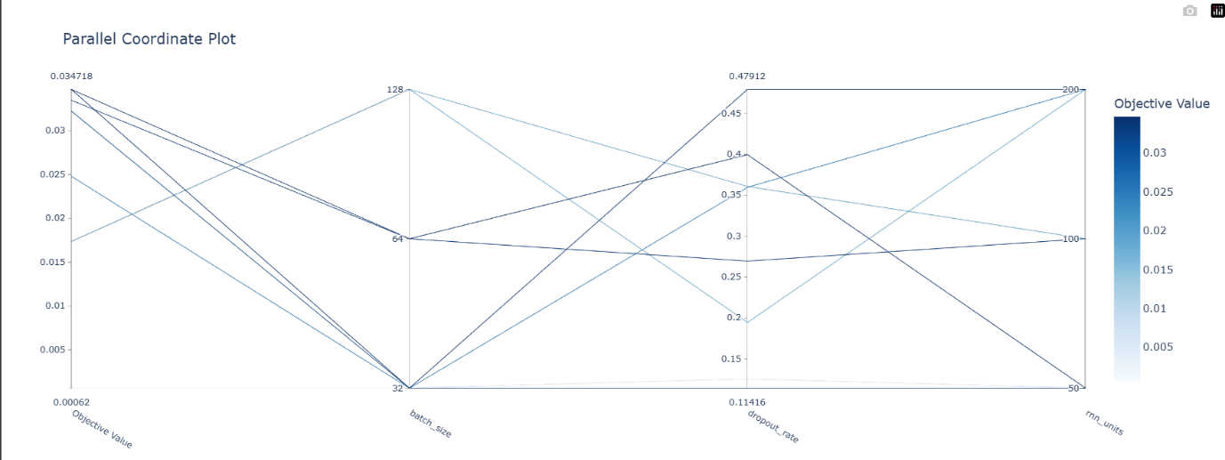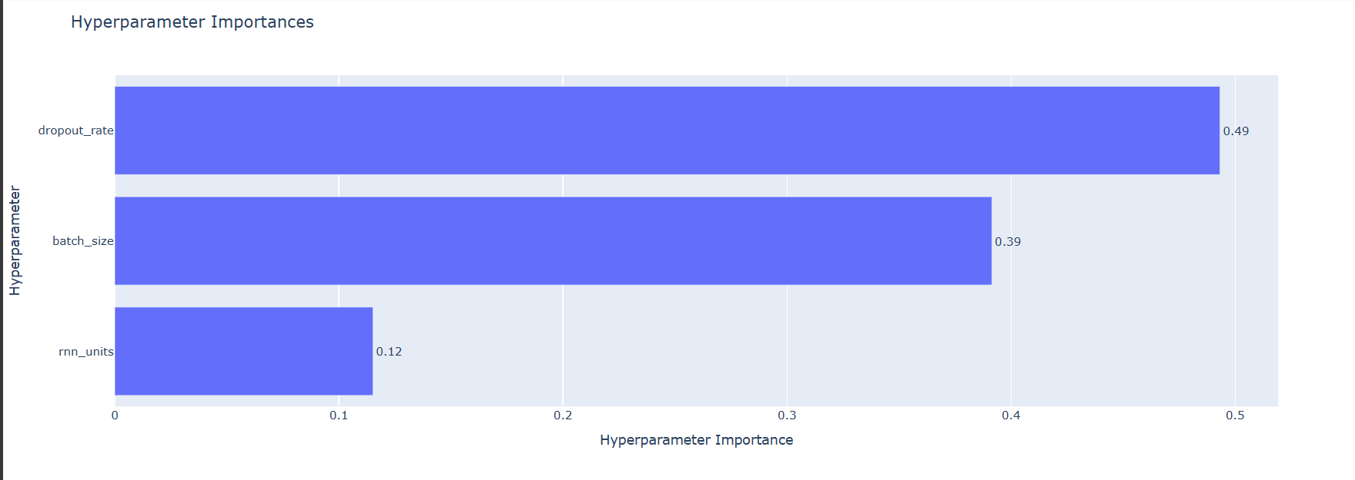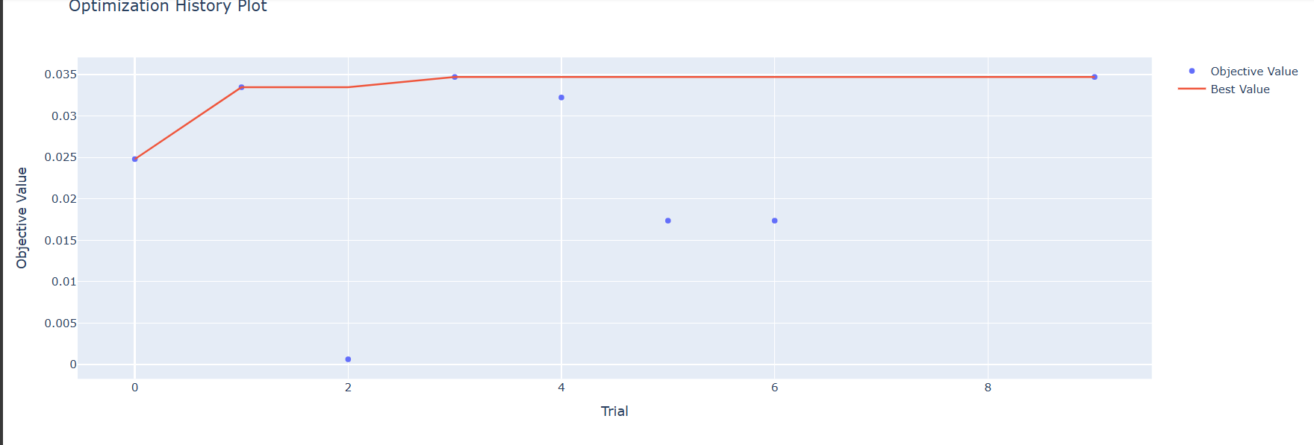

The charts show that smaller batch sizes typically yield higher accuracy in certain particular configurations. Smaller batch sizes may also enable the addition of additional noise to the gradient updates, thereby avoiding local minima during optimization.   
  
Conversely, it appeared that the ideal dropout rate value fell between 0.2 and 0.3, which strikes a balance between letting the model extract the necessary information from the input and avoiding overfitting the training data. Furthermore, RNN units of order 50 produced the best results, therefore this dataset and model setup can, if not preferable, be used with smaller units. This is probably because of the rather basic data patterns that do not require the use of much complex models.

**Interpretation of Model Performance Variations Across Different Configurations:**

The hyperparameter significance graph provided more insight into the factors that had the most effects on the model's performance. It is evident that the batch size, dropout rate, and number of RNN units are the three most crucial hyperparameters. If that outcome is considered, it may be concluded that altering the batch size can improve model performance more than altering the regularization techniques or model complexity alone.

The optimization history figure that follows provides a clear illustration of this, with an overall rising trend in the objective value as the trials go on, albeit with variations that highlight the training process's stochastic nature. For the specific value of the batch size, dropout rate, and rnn_units that produced the best trial, in relation, gave me a validation accuracy of about 0.03471.   
All things considered, the analysis highlights the significance of exercising caution, particularly when methodically adjusting hyperparameters using an automated tool such as Optuna for experiments that would provide the model's optimal performance in tasks pertaining to natural language processing.

**Summary and Conclusions**

**Recap of Key Findings and Their Implications:**

**Model Performance:** When it came to text production, the final recurrent neural network (RNN) did well; however, it excelled in creating news headlines.   
The essential performance increased as result of the hyperparameter adjustments indications with higher validation accuracy in the optimal configurations.   
  
**The impact of hyperparameters**: Significant new data regarding the influence of hyperparameters on the model, including batch 11 size, dropout rate, and the number of RNN units, has been provided by the Optuna visualizations. Therefore, it suggests that, particularly in issues involving natural language processing, the highest level of accuracy during parameter tuning is required to achieve the optimal trade-off between overfitting and model complexity.

**Efficient Tuning:** Optuna's implementation of this hyperparameter optimization strategy methodically looked for the ideal model configurations, which improved both the training process and the model's output. The effectiveness of this approach in comparison to other approaches enables the adoption of a more targeted and effective approach when fine-tuning the models.

**Limitations of the Current Study:**

**Dataset Limitations**: Because the study only used the dataset of news headlines, it may not have offered a thorough assessment of the model's performance on more difficult text production tasks or under other linguistic scenarios.   
**Model Simplicity:** SimpleRNN is computationally less expensive than the others, but it could not be as good at modeling long-term dependencies as more sophisticated models like LSTM or GRU, which could have an impact on the text's quality.

**Suggestions for Future Research Directions:**

**More complex topologies:** More complex neural network topologies, like transformer-based or LSTM models, would be studied in order to gain a better understanding of how to capture nuances and long-range relationships inside textual data **Cross-Linguistic Applications:** One of the main concerns in the global use of NLP is the model's adaptability and effectiveness in multilingual contexts, which may be demonstrated by its use across various languages and dialects. **Integration of Outside Information:** In addition, incorporating external knowledge bases or context embeddings may improve the model's comprehension and text production, producing more reliable and expressive results.

**References:**

1. Guo, M., Yi, T., Zhu, Y., & Bao, Y. (2021). JITuNE: Just-in-time hyperparameter tuning for network embedding algorithms. In arXiv [cs.LG] http://arxiv.org/abs/2101.06427
2. Im, D. J., Savin, C., & Cho, K. (2021). Online hyperparameter optimization by real-time recurrent learning. In arXiv [cs.LG]. <http://arxiv.org/abs/2102.07813>
3. Li, Yang, Shen, Y., Jiang, H., Zhang, W., Li, J., Liu, J., Zhang, C., & Cui, B. (n.d.). Scalable Data Science. Arxiv.org. Retrieved May 10, 2024, from <http://arxiv.org/abs/2201.06834>
4. Li, Yaru, Zhang, Y., & Cai, Y. (2021). A new hyper-parameter optimization method for power load forecast based on recurrent neural networks. Algorithms, 14(6), 163. <https://doi.org/10.3390/a14060163>
5. Liao, L., Li, H., Shang, W., & Ma, L. (2022). An empirical study of the impact of hyperparameter tuning and model optimization on the performance properties of deep neural networks. ACM Transactions on Software Engineering and Methodology, 31(3), 1–40. https://doi.org/10.1145/3506695